**UI Design Analysis**

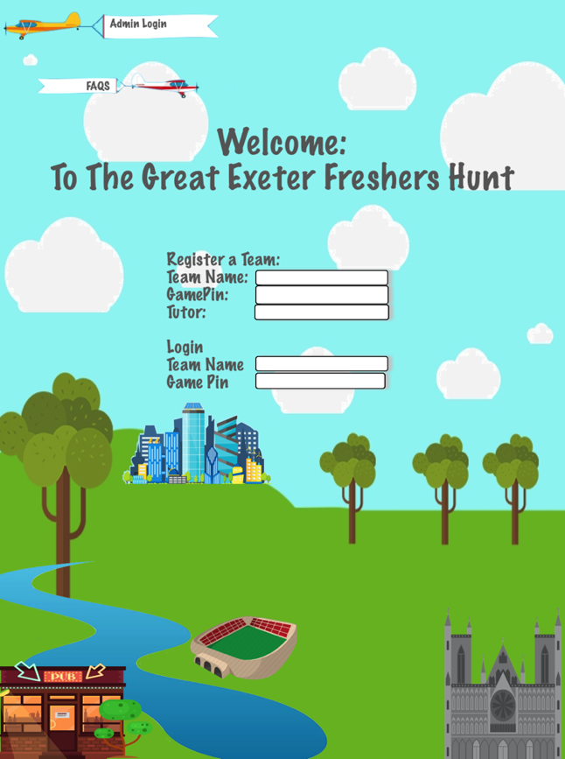

**General Features**

We updated our design for the UI to move away from the simplistic, easy colour scheme and more towards a colourful and interesting design. This should help the enjoyment of the users, as the previous design was too boring to be used on an interactive game. By using bright colours and a cartoon style, it should interest the user and interest them more in the game. The main function of the application is to lead the user around the campus in a fun and interactive way and by making the application more fun to look at, this should help make it more fun to use as well.

We’ve used dark grey text to contrast the light blues and greens in the background, as the dark grey is a colour that isn’t used anywhere else on the background. This ensures that the text is easy to read and clear for the user. We are also using this grey for to outline of the boxes so that they are also clear on the page.

The background is designed to represent the city of Exeter. The clipart used in it shows some of the most prominent features of the city, including the river, the football stadium, and the university itself on top of the hill. This is so that the new students using the app can get a feel for the city itself and what is available there, despite the application only directing them around the university campus. It is important to us that we deliver a wider perspective of Exeter as a whole and that the students have some understanding of the city outside the university campus.

We chose to centre align all of the elements on our application to ensure a professional look regardless of the size of display. The app will be used on mobile devices which will therefore vary in size depending on the device. It is important that our app looks equally good on every device, and therefore centre aligning means that the spacing either side of the elements will be even no matter the size of the device it is deployed on. This helps to keep a balanced and smart look to the product.

Welcome Page

On the welcome page, we clearly separated the different sections for the user to register and log back in. This should prevent confusion and ensure that it is straightforward and simple to use. There will also be a button at the top of the page for admins to log in. This will be clear enough for the gamekeepers who will need to use it, but will also be small enough that the standard users won’t accidentally click on it.

Dashboard

The dashboard shows the user’s progress through the hangman style revealing of letters at the top of the page. This helps to incentivise the teams throughout the use of the app as it will be the first thing that is seen when the app is opened. It is also the end goal of the user to complete this and reveal the room so that they can finish. It is vital information that the user needs to complete the treasure hunt and meet their tutor, so it therefore has to be prominent within the app. The locations are next to checkboxes that will be ticked once a location has been completed. This prevents the teams from accidentally repeating locations and allows them to focus on enjoying and completing the treasure hunt. The button to open the camera will be next to the list of locations so that the teams can easily find it when looking at the location they’re at. At the top of the dashboard will be links to a map showing the locations, the leader board, and extra information and FAQs. The links will be displayed in a navigation bar at the top so that they are clear and easy to find.

Frequently Asked Questions

The FAQs page will be extremely simplistic in layout, with a list of common questions, followed by an answer to them. This page will be as simplistic as possible to prevent any further confusion/frustration for the user.

Map

The map page will also be very simple, containing only a large map of the university followed by the list of locations and a checkbox for if they’ve been completed. This is done once again to stop any extra confusion to the teams using the app.

Admin/Gamekeeper

The admin login pages and gamekeeper dashboard will be optimised for use on a desktop PC or laptop, as these will be the primary devices that these pages are used on. Therefore, they will utilise the wider screen and landscape pattern to full effect.

On the gamekeeper dashboard, the buttons and actions that they can do are down the left-hand side and easily accessible. Alongside these will be the list of teams in the current game and their progress in the game, as shown by the letters that they have collected. This means that once a game has been fully set up, the gamekeeper only needs to focus on the right-hand side and the current position of the teams.

